Benjamin Jusufovic
Curtis Mayberry
Thinh Luong
Ben Cao

Week 5
Purpose:
The purpose of this report is to highlight the progress that our team has made in the initial steps of our senior design project (F10-19).
Progress:
Throughout week 5, our group has continued to research the main components of the steam valve controller user interface as well as the controller unit. We also met to discuss our project plan and project cost analysis.
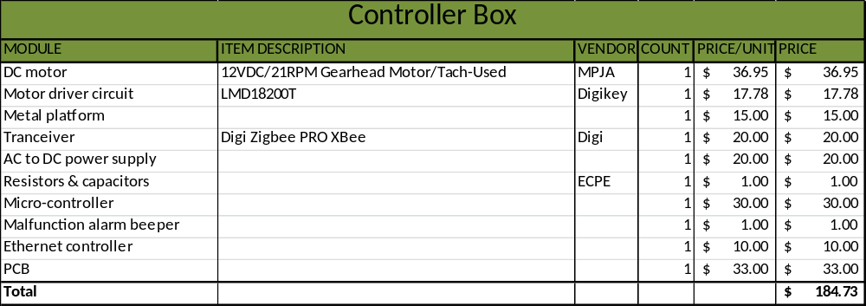
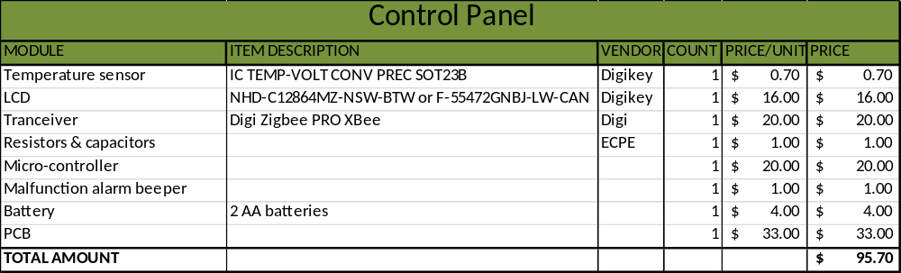
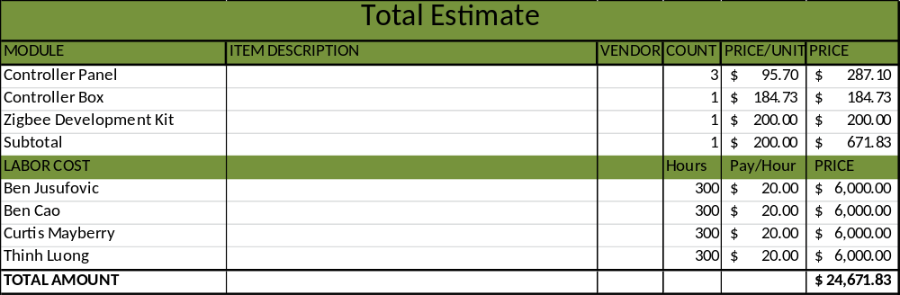
Completed:

- Project plan.
- Project cost analysis.
- Obtained electronic lab kit & motor driver circuit LMD18200T to test
Goals for next week:

- Complete parts/components order for the ecpe resource department
- Functional testing circuit for motor driver LMD18200T
- Begin testing of components and low level design work.

